

BAHRIA UNIVERSITY ISLAMABAD

ROBOTICS LAB

LAB 3: ROBOT OPERATING SYSTEM - 2

Name of Student: ………OMAR…………………………………….

Roll No.: 01-132182-024……………………………………………………………….

Date of Experiment: ………………………………………………….

Report submitted on: ………………………………………………..

Marks obtained: ……………………………………

Remarks: ……………………………………………

Instructor’s Signature: ……………………………...

Fall 2021

# **OBJECTIVES:**

* To Set up simple publisher and subscriber nodes and visualize their working in terminal.
* Create a custom message.
* Run multiple nodes at once using roslaunch.
* Record your experiment in .bag file.

# **Tasks**

* Create a publisher and subscriber node, compile it using “catkin_make” and run the nodes. Attach the screenshots and describe publishing node is publishing which message to what topic and similarly subscribing node is subscribing to which topic.
* Create a custom message, publish it from one node and subscribe it from another node.
* Create launch a launch file and run both publisher/subscriber node using single command. • Capture the environment using rosbag and run it and attach the screenshots.

**CODE:**

$ mkdir scripts

$ cd scripts

$ wget https://raw.github.com/ros/ros_tutorials/kinetic-devel/rospy_tutorials

/001_talker_listener/talker.py

$ chmod +x talker.py

catkin_install_python(PROGRAMS scripts/talker.py

DESTINATION ${CATKIN_PACKAGE_BIN_DESTINATION}

)

$ roscd beginner_tutorials/scripts/

$ wget https://raw.github.com/ros/ros_tutorials/kinetic-devel/rospy_tutorials /001_talker_listener/listener.py

$ chmod +x listener.py

catkin_install_python(PROGRAMS scripts/talker.py scripts/listener.py

DESTINATION ${CATKIN_PACKAGE_BIN_DESTINATION}

$ roslaunch [package] [filename.launch]

TASKS:

**1-Making CMake lists:**

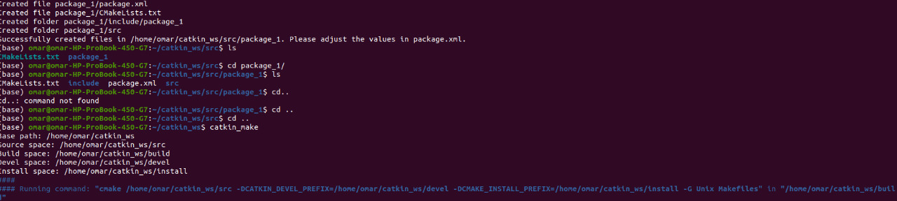

**2-To run BASH command:**

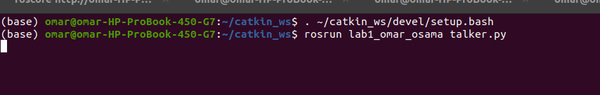

# **3-ros node , ros list & displaying our own created random message:**

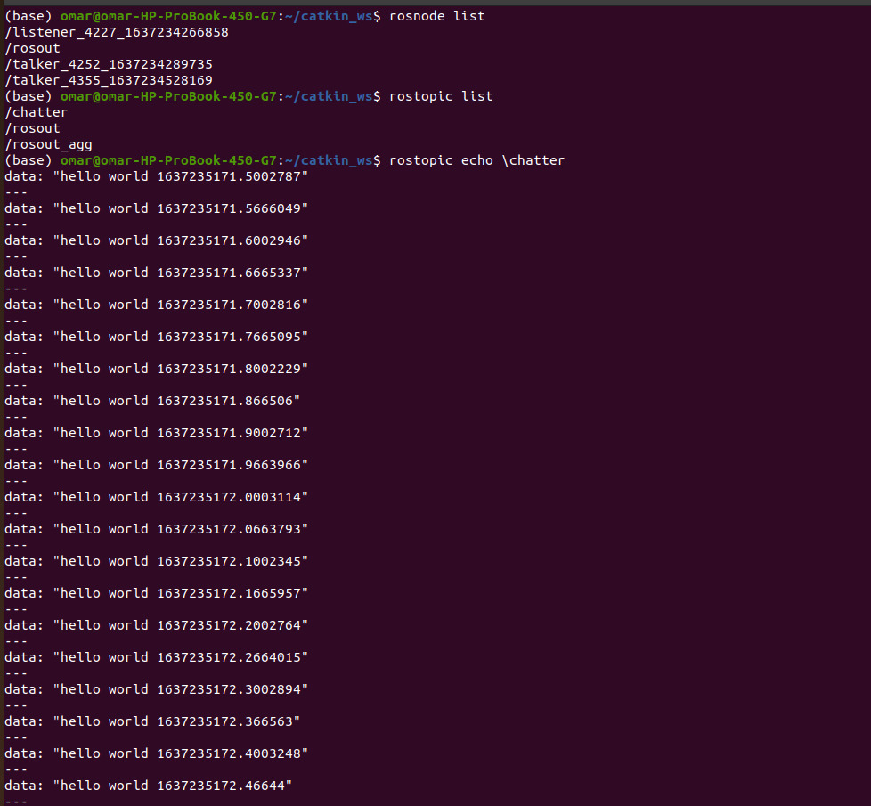

**4-Reading our message at subscriber node:**

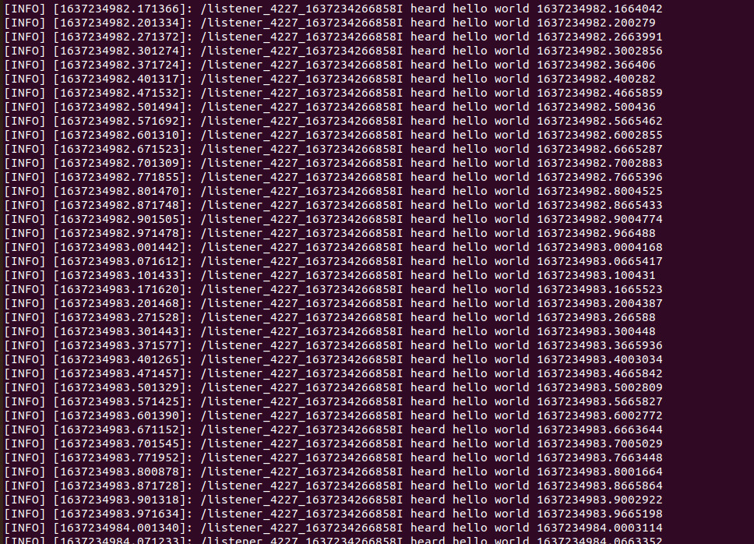

# **5-running our talker.py our publisher node:**

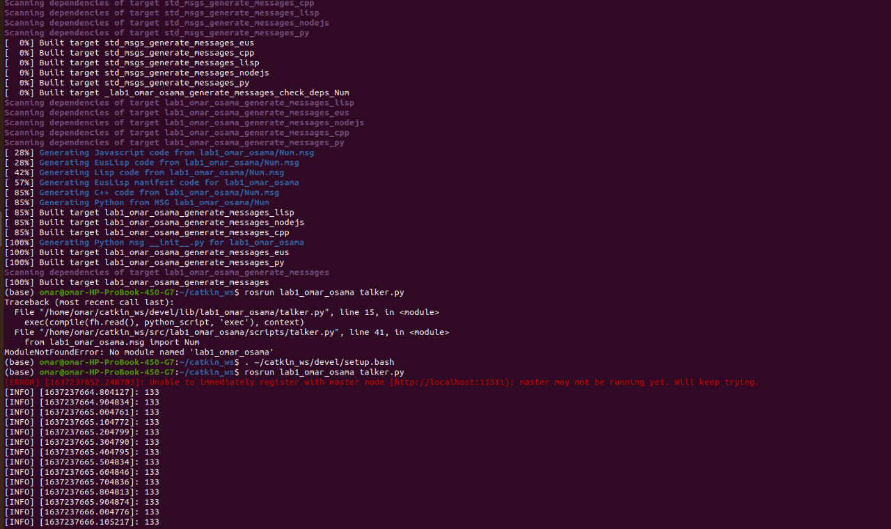

# **6-Processing our catkin package:**

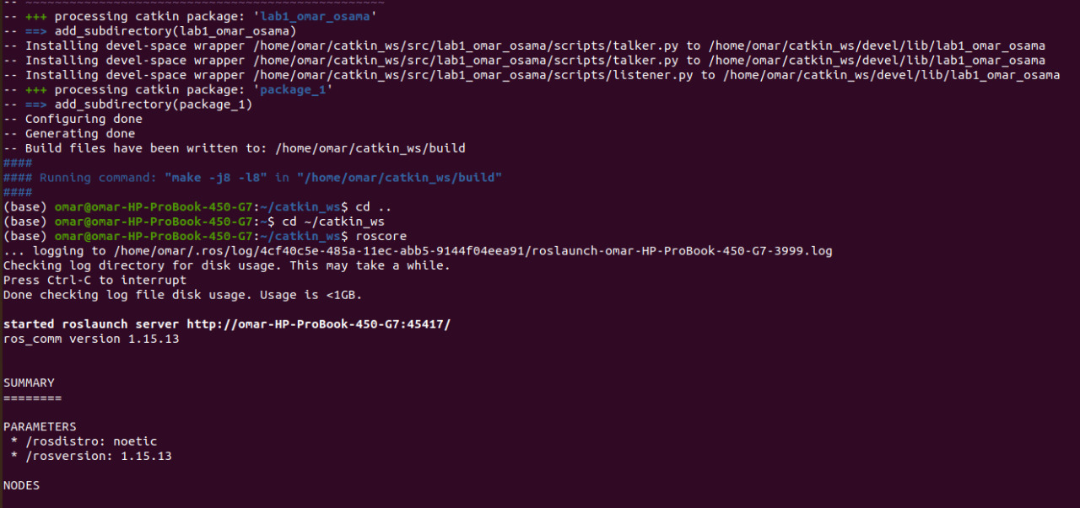

**7-chmod talker.py:**

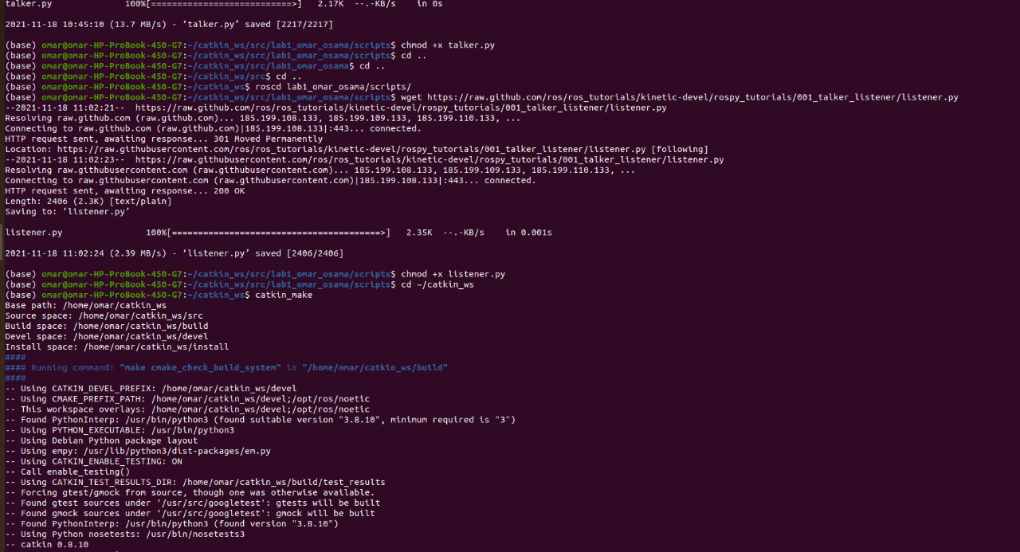

# **8-making directory scripts:**

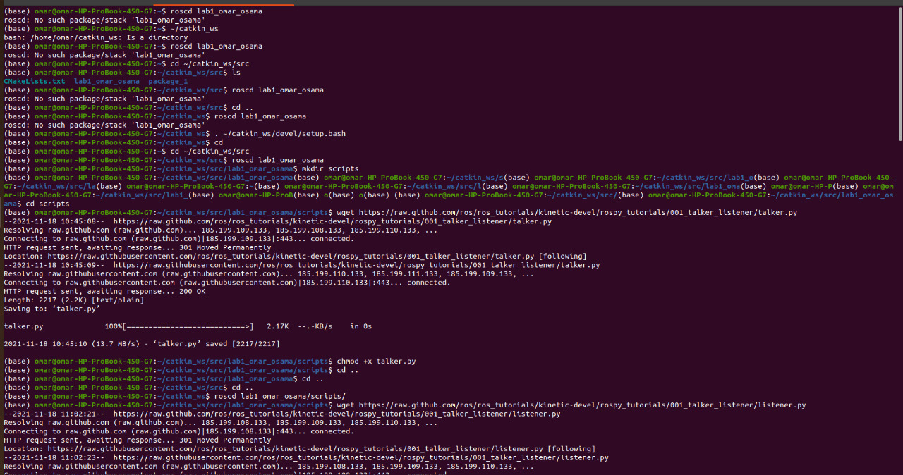

# **9-Building our environment by7 running roscore:**

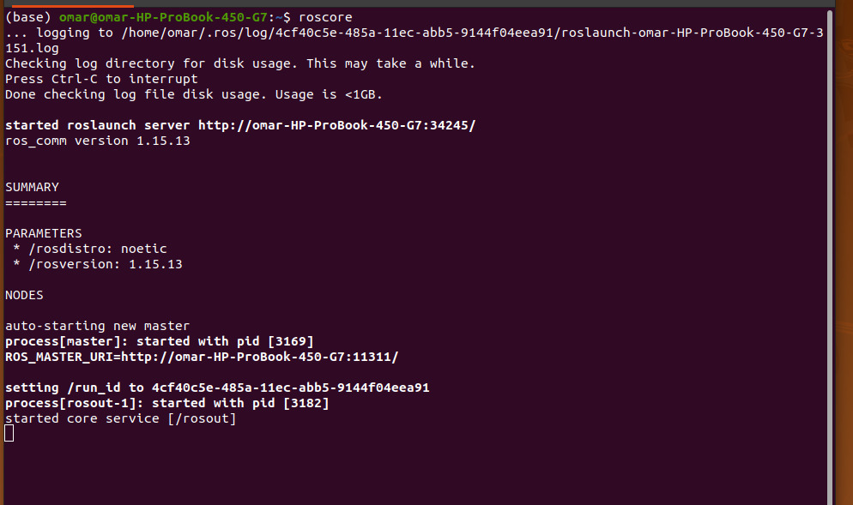

**10- Output of rosnode list :**

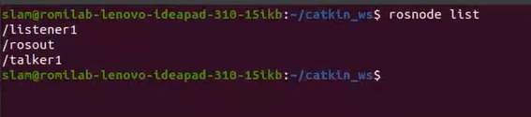

**11-Output of rostopic echo /chatter**

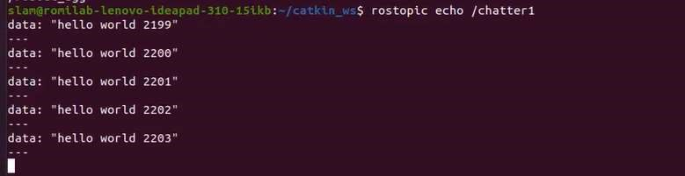

# **10-talker.py**

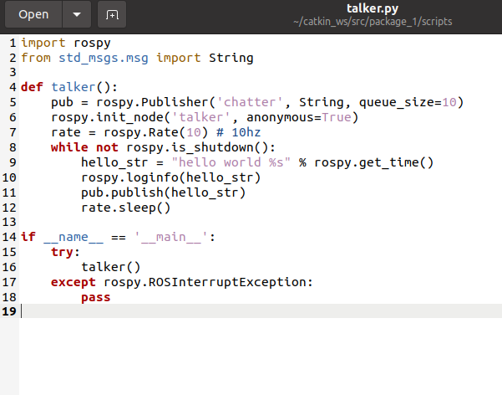

11-Listener.py

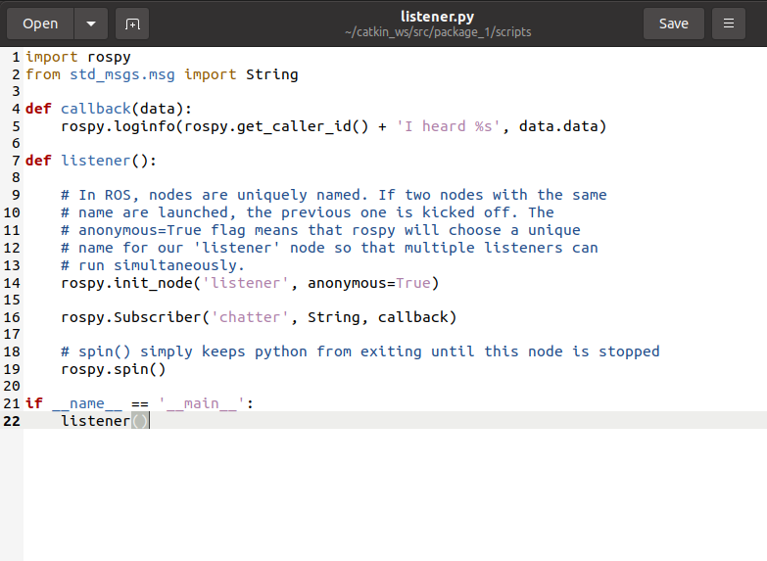

# 

**12-Cmakelists.txt :**

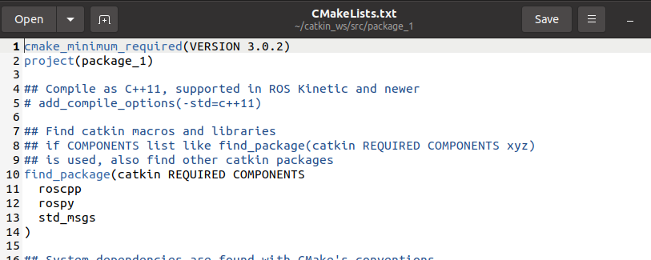

* **Conclusion:** Today we learne3d about how to establish subscriber and publisher nodes and then allow them to communicate together using a topic. And the message used in communication was also generated by me (custom message).